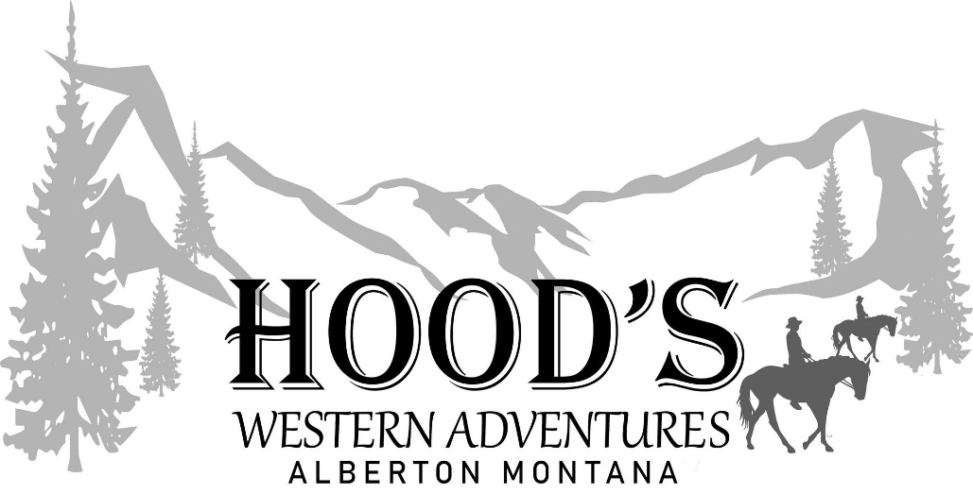
2021
ASSUMPTION OF RISK AND RELEASE OF LIABILITY FOR RIDING, ARENA USAGE, EVENTS, CLINICS, FACILITY RENTAL AND
RELATED BOARDINGAND/OR RIDING ACTIVITIES:
In consideration of participation in clinics, events, facility rental, lessons/training of horses, and any related boarding and stalling of any horse(s), provided or personal at the grounds and arena owned by Hood’s Western Adventures, LLC (Owen and Kailey Hood) located at 885 Juniper Lane, Alberton, Montana 59820.
I hereby waive, release and forever discharge any and all rights and claims for injury or damages which may have or which may hereafter occur to myself, minor(s) I’m signing for, any person(s) accompanying me or my horse(s), against Hood’s Western Adventures (Owen and Kailey Hood), and their heirs, agents, representatives, employees, trainers, clinicians and/or sponsors, for any and all injuries and damages which may be sustained by me, minor(s) I’m signing for, any person(s) that may have been accompanying me or my horses(s), while riding, attending clinics, events, or using the facility or arena in any way from any person, either with my own horse or with a horse provided, and any related boarding or stalling of my horse(s) on the property, and/or the use of the grounds, facility or arena owned by Hood’s Western Adventures (Owen and Kailey Hood).
I recognize that horses are unpredictable animals and that there are significant risks of injury inherent and associated with horses and horse related activities, including, but not limited to catching, trailering, loading, boarding, riding, training, lessons, grooming, saddling, leading, feeding, and caring for horses. Knowing the inherent risks, dangers, and rigors involved in such horse activities, I certify that I understand the risks associated therewith, that I or the minor(s) I’m signing for are fully capable of participating in any activities on the premises or participation in clinics or lessons for myself, ride, use the facility in any way at my own risk.
I assume full responsibility for any and all risks of bodily injury, death, loss or injury to personal property, damages and any and all expenses associated therewith, both for myself, minor(s) and for my horse(s). I further agree to be responsible for all damages or injuries caused by myself, minor(s) or my horse(s) to the property, facilities, other persons, other horses, and other person’s property, and shall indemnify and hold Hood’s Western Adventures (Owen and Kailey Hood) harmless from such damages or injury caused by my horse(s) Or The horses provided by Hood’s Western Adventures (Owen and Kailey Hood)
NAME AND SIGNATURE OF RIDER(s)_____________________________________________________________________
__________________________________________________________________________________________________
SIGNATURE OF PARENT OR GUARDIAN OF MINOR(s)_______________________________________________________
ADDRESS__________________________________________________PHONE__________________________________
Pictures approved for social media content. YES______NO_______ DATE________________________

